Task 1: SOHO Network Architecture Diagram

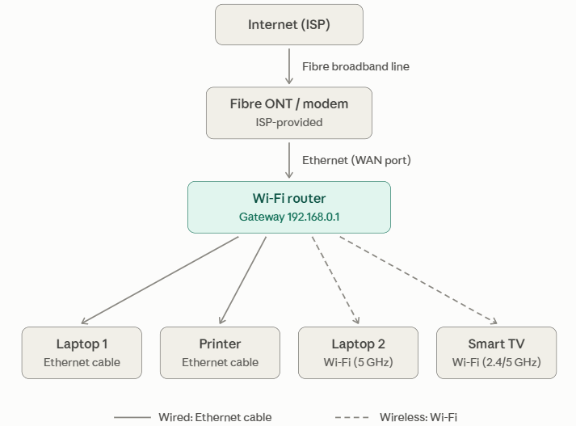

Task 2: Hardware Specifications to physically build SOHO network

The following components represent standard, high-reliability equipment available on Indian e-commerce marketplaces (Amazon India / Flipkart):
Item | Component | Suggested Brand & Model | Specifications & Interfaces | Role in Network
1 | Wi-Fi 6 Router / Gateway | TP-Link Archer AX23 (or D-Link DIR-X1560) | Dual-Band Wi-Fi 6 (1201 Mbps on 5 GHz + 300 Mbps on 2.4 GHz), 1× Gigabit WAN, 4× Gigabit LAN ports, WPA3/WPA2-PSK support. | Central default gateway, DHCP server, NAT engine, and wireless access point.
2 | Broadband Termination | Airtel Xstream / JioFiber ONT (or Syrotech GPON ONT) | 1× SC/UPC optical fiber input port, 1× Gigabit RJ-45 Ethernet bridge output port. | Translates optical fiber pulses from the ISP local loop into copper Ethernet data.
3 | Network Printer | HP Smart Tank 580 (or Brother DCP-T820DW) | Built-in 10/100 Ethernet (RJ-45) and Wi-Fi 802.11b/g/n, automatic duplex printing. | Shared local network printer accepting documents across the LAN.
4 | Smart Display | Samsung Crystal 4K iSmart 43" (or LG UR7500) | 1× RJ-45 Fast Ethernet port, Wi-Fi 5 (802.11ac), webOS/Tizen smart platform. | Media consumption and office screencasting.
5 | Client Laptops (×2) | Dell Inspiron 15 / Lenovo ThinkPad E14 | Intel Wi-Fi 6 AX201 / Realtek 802.11ax NIC, integrated Bluetooth 5.2. | Primary client computing nodes.
6 | Ethernet Patch Cables | Amazon Basics / Terabyte Cat6 UTP Patch Cords | 24 AWG stranded copper, 550 MHz bandwidth, factory-molded RJ-45 snagless boots (1m to 3m lengths). | Hardwiring the ONT to router WAN, and connecting the Smart TV and Printer to router LAN ports.
7 | Power Protection | APC Back-UPS BX600C-IN (600VA / 360W) | 3× India 3-pin output sockets, surge and spike suppression, battery backup. | Prevents router drops, packet errors, and memory corruption during power cuts.

Task 3: WIFI Router Configuration Guide (Step-by-Step)

Step 1: Connect the Router
- Connect the broadband ONT/modem to the router's WAN/Internet port.
- Connect the router to power.
- Connect a laptop to the router using Ethernet or the default Wi-Fi network.
Step 2: Open Router Configuration
- Open a web browser.
- Enter the router's gateway address, for example: 192.168.1.1
- Log in using the router's default credentials.
- Change the default administrator password immediately.
Step 3: Configure Internet Connection
- Open Internet/WAN Settings.
- Select the connection type provided by the ISP:
- Dynamic IP (DHCP): Standard if the ISP ONT acts as a primary bridge/gateway.
- PPPoE: Enter the broadband username and password provided by the ISP (e.g., Airtel/BSNL fiber PPPoE accounts).
- Static IP
- Enter the required ISP details.
- Save the configuration.
Step 4: Configure Wireless Settings (SSID & Encryption)
- Navigate to Wireless Settings (or Network $→$ Wireless).
- Set a custom, recognizable SSID (Network Name) that avoids personal identifiers:
- GHz SSID: Apex_Office_2.4G
- 5 GHz SSID: Apex_Office_5G (or enable Smart Connect to broadcast a single SSID Apex_Office_Secure).
- Set Security Mode to WPA2-PSK (AES) or WPA2/WPA3-Personal Transition Mode.
- Set the Pre-Shared Key (Wireless Password) to a secure passphrase (e.g., NetPlus@WorkSafe99).
- Confirm Channel Width is set to Auto (20/40 MHz for 2.4 GHz; 20/40/80 MHz for 5 GHz).
- Click Save.

Task 4: IP Addressing & Device Reservation Scheme
- Subnet: 192.168.1.0/24
- Subnet Mask: 255.255.255.0
- Default Gateway (Router): 192.168.1.1
- DNS Servers: 1.1.1.1 (Cloudflare Primary), 8.8.8.8 (Google Secondary)
- DHCP Dynamic Pool: 192.168.1.100 – 192.168.1.200
- Static / Reserved Block: 192.168.1.2 – 192.168.1.99
Device Name | Connection Type | MAC Address | IP Assignment Type | Assigned IPv4 Address
SOHO Gateway | Internal Backplane | C8:3A:35:11:A0:01 | Static (Fixed Core) | 192.168.1.1
Network Printer | Wired (Cat6 LAN) | 00:1B:78:3A:4C:12 | Static (DHCP Reservation) | 192.168.1.10
Smart TV | Wired (Cat6 LAN) | D4:E6:B7:89:12:F4 | Static (DHCP Reservation) | 192.168.1.20
Laptop 1 | Wireless (Wi-Fi 6) | 3C:52:82:44:9B:AA | Dynamic (DHCP Pool) | 192.168.1.101
Laptop 2 | Wireless (Wi-Fi 6) | 70:69:79:E1:8F:B3 | Dynamic (DHCP Pool) | 192.168.1.102

Task 5: Troubleshooting: Laptop Cannot Connect to Internet

Cause 1: Physical or wireless connection problem
- Symptoms: no Wi-Fi networks listed, "no internet" icon, or the Ethernet link light is off.
- Diagnose: check that airplane mode is off and the Wi-Fi switch is on. For Ethernet, check that the cable is seated and the port LEDs are lit, and try another cable or port. For Wi-Fi, check the signal strength and that the right password was entered.
- Fix: turn Wi-Fi on, "forget" the network and reconnect with the correct password, replace the bad cable, move closer to the router, or switch to the 5 GHz band if 2.4 GHz is congested.
Cause 2: IP configuration or DHCP failure
- Symptoms: connected to the network but no internet, or an address like 169.254.x.x (Automatic Private IP Addressing - APIPA).
- Diagnose: run ipconfig /all (Windows) and check for a valid 192.168.0.x address, gateway 192.168.0.1 and mask 255.255.255.0. Then run ping 192.168.0.1 to test the router.
- Fix: set the adapter to obtain an IP automatically, run ipconfig /release and ipconfig /renew, and restart the router if DHCP is not responding. If someone set a static IP on the laptop, check it is not outside the subnet or conflicting with the printer or TV.
Cause 3: DNS problem
- Symptom: The laptop can connect to raw public IP addresses, but standard web pages (e.g., google.com) fail to open with DNS_PROBE_FINISHED_NXDOMAIN. Other LAN devices (Smart TV, Laptop 2) can reach the internet normally.
- Diagnosis:
- Test Layer 3 transit directly to Cloudflare's public Anycast DNS IP: ping 1.1.1.1
Result: ICMP Echo replies are received successfully (proves physical link, gateway routing, and ISP WAN are functional).
- Test domain name lookup using nslookup: nslookup www.google.com
Result: Command times out or outputs Server: UnKnown / Query refused.
- Resolution Steps:
- Clear out corrupt local operating system DNS cache entries: ipconfig /flushdns
- Check the laptop's network adapter settings (ncpa.cpl) to verify whether static, invalid DNS IP addresses were accidentally configured.
- Switch the adapter DNS configuration to Obtain DNS server address automatically or manually assigns reliable resolvers:
- Preferred: 1.1.1.1
- Alternate: 8.8.8.8
Cause 4: Router, ISP or access settings
- Symptoms: ping 192.168.0.1 works but ping 8.8.8.8 fails, and other devices are also offline.
- Diagnose: check the ONT's Internet/PON LEDs and the router's WAN status page. Also check whether MAC filtering or parental controls are blocking this laptop.
- Fix: restart the ONT, then the router, and check the Ethernet cable between them. Remove the laptop from any block list, and call the ISP if the WAN still shows disconnected.

Cause 5: Laptop software or driver fault
- Symptoms: the Wi-Fi adapter is missing or shows an error, or the problem appears only on this laptop after an update.
- Diagnose: open Device Manager and check the network adapter, and run the built-in Windows Network Troubleshooter.
- Fix: update or roll back the driver, disable and re-enable the adapter, run netsh winsock reset and netsh int ip reset, then restart.
Conclusion
- The SOHO network uses a Wi-Fi router as the central networking device. Laptops obtain their IP addresses automatically through DHCP, while the printer and Smart TV use static IP addresses. WPA2 security, a unique SSID, and a changed administrator password help secure the network. Basic commands such as ipconfig, ping, and nslookup can be used to identify and troubleshoot common connectivity problems.

